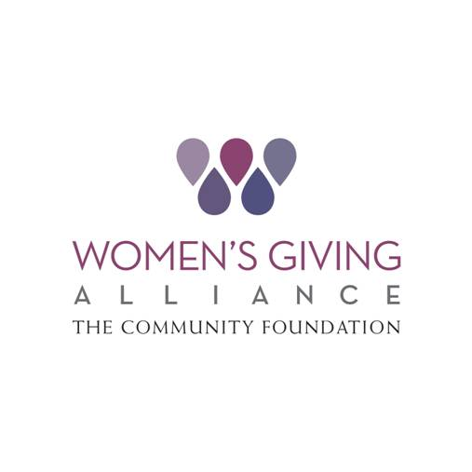
www.wganefl.org
Advocacy Toolkit

The Power of One:
Effective Personal Advocacy
January 2016

The Advocacy Committee of Women’s Giving Alliance
Table of Contents
What is advocacy? 1
How to use this Toolkit 2
Steps for advocacy 3
Sample advocacy letter 5
Advocacy Committee Information 6
Women’s Giving Alliance
Advocacy Tool-Kit:
A project of the Advocacy Committee

What is advocacy?

As described in The Community Foundation’s recently released “Public Policy and Advocacy Activities Policy,” advocacy is defined as follows:

A broad term that encompasses a range of activities designed to educate and influence others through issue analysis, community organizing, and relationship-building

Advocacy can take a lot of different forms from lobbying elected officials in person to sending a letter to simply signing a petition. In fact, you are probably already an advocate – speaking to your family and friends about your views on an issue or voicing your concerns to your child’s teacher – these are exercises in advocacy. So what does WGA mean, when we talk about empowering our members to be advocates? In the WGA context, advocacy is simply “Making Change Happen.”

How to use this tool-kit

This tool-kit is designed to help you be a more effective advocate as an individual. It includes a model letter and contact resources for most of our local elected officials. When you feel passionately about an issue, we wanted it to be easy for you to take action and voice your point of view to the appropriate decision makers.

Please note: This document is not intended as license or authorization to use your affiliation with WGA as a part of your individual advocacy. WGA has a separate process for vetting and approving issues that goes through the Executive Committee and the Community Foundation board. No WGA member should represent her personal views as those of the entire organization without prior authorization by this extensive process.

Steps to advocacy

The questions below are intended to provide a framework for organizing your approach when starting an advocacy project.

Step 1: What’s the problem you are trying to address?
Before embarking on any project, it’s important to define the core issue and ensure you understand what you are trying to change.

Step 2: What’s your objective?
Do you want more funding for your cause? Do you want legislation approved or defeated? Identify exactly what you want as an outcome from the outset so you can plan accordingly.

Step 3: Do you have all the facts?
Research your issue and make sure you have all the information you need to support your argument. Identify other stakeholders who might be able to help as well. It is important to also thoroughly research the opposition’s argument so that you will be able to respond to their position.

Step 4: Who is the decision maker?
Identify who has the ability to drive change on this issue and who has the power to achieve your objective.

Step 5: How can you best influence the decision?
Is sending a letter the most effective method? Are there meetings or forums that you may want to be a part of? Are there other tools – like sending a letter to the editor or using social networking tools that you should also employ?

Step 6: Who else can help reach the decision maker?
Use your networks to let your friends and family know that you are getting involved and ask that they do the same as individuals. Start a movement!
SAMPLE ADVOCACY LETTER

Advocacy letters should be concise, compelling, and easy to understand. Below you’ll find a sample letter (based on Dr. Seuss’s ecological story The Lorax) with key sections labeled.

Make sure you properly address your decision-maker:
Company Name
Street Address
Address 2
City, ST ZIP Code

Phone (325) 555-0125
Fax (325) 555-0145

Web site address

Dear Senator Rubio:

Put your request up front and be clear why you are asking for that:

I’m writing to ask you to please vote NO on Bill XXYY-28, which would directly jeopardize the health and safety of our state’s truffala tree forest.

Give your credentials (voter, mother, citizen, etc.). Note that unless it is an issue that has been official authorized by the WGA Executive Committee and the Community Foundation Board, you should not use your WGA membership as part of your credentials.

Provide supporting details and information for your argument.

As a Jacksonville resident and voter, I appreciate the role that the forest plays in enhancing the beauty of our region and the importance of the trees in ensuring we continue to protect our air quality. Additionally, the famous truffala trees draw many tourists from around the world and are key to the economic health of our region.

Please stand up against this shortsighted bill, which would literally be missing the forest for the trees.

Sincerely,

The Lorax (who speaks for the trees)
1421 Avondale
Jacksonville, FL 32205

Be sure to include your contact information!
CONGRESSIONAL CONTACTS:

President
Barak Obama (202)456-1111 (switchboard); The White House, 1600 Pennsylvania Ave., NW, Washington, DC 20500; www.whitehouse.gov/contact/submit-questions-and-comments
US House
- Corinne Brown, D-FL, (5th) (904)354-1652; house.gov/corinnebrown
- Ander Crenshaw, R-FL, (4th) (904)598-0481; Crenshaw.house.gov
- Ron DeSantis, R-FL, (6th) (386)756-9798; desantis.house.gov
- Ted Yoho, R-FL, (3rd) (202)225-5744; cong.yoho@mail.house.gov
US Senate
- Bill Nelson, D-FL, (904)346-4500; billnelson.senate.gov
- Marco Rubio, R-FL, (904)398-8586; rubio.senate.gov
Florida House
- Janet H. Adkins, R-Fernandina Beach, Distict 11; Nassau, Duval; (904)491-3664; janet.adkins@myfloridahouse.gov
- W. Travis Cummings, R-Orange Park, Dist. 18; Part of Clay; (904)278-5761; travis.cummings@myfloridahouse.gov
- Jay Fant, R-Jacksonville, Dist. 15; Part of Duval; (904)381-6012; jay.fant@myfloridahouse.gov
- Reggie Fullwood, D-Jacksonville, D. 13; Part of Duval; (904)353-2180; reggie.fullwood@myfloridahouse.gov
- Mia L. Jones, D-Jacksonville; District 14; Part of Duval; (904)924-1615; mia.jones@myfloridahouse.gov
- Charles McBurney, R-Jacksonville; District 16; Part of Duval; (904)359-6090; charles.mcburney@myfloridahouse.gov
- Lake Ray, R-Jacksonville, District 12; Part of Duval; (904)723-5300; lake.ray@myfloridahouse.gov
- Cyndi Stevenson, R-St. Johns, District 17, Part of St. Johns; (904)273-4466; cyndi.stevenson@myfloridahouse.gov

www.wganefl.org

